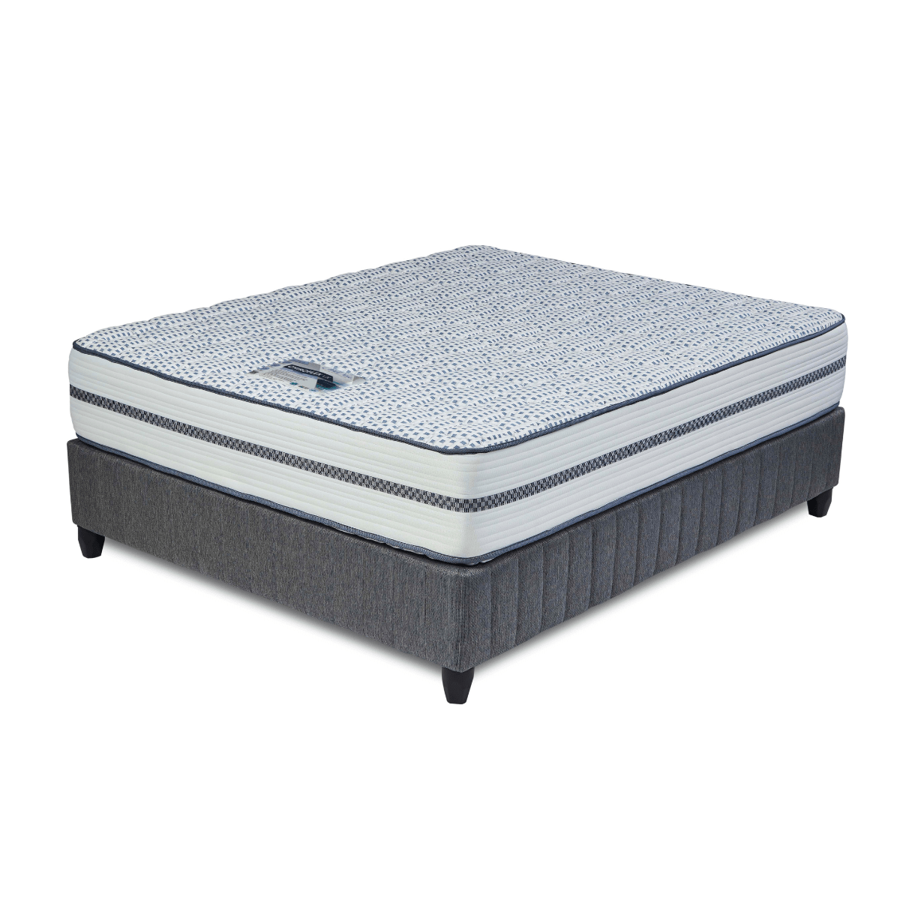


Model : Chiroflex Bed Set
Supplier/Manufacturer : Cloud Nine
Range : Ultra Premium
Prices – Bed Set :
- Single Bed Set – R11519
- Three Quarter Bed Set – R13269
- Double Bed Set – R16379
- Queen Bed Set – R17989
- King Bed Set – R22329
Prices – Mattress Only :
- Single Mattress Only – R9869
- Three Quarter Mattress Only – R11439
- Double Mattress Only – R14359
- Queen Mattress Only – R15909
- King Mattress Only – R19019
Prices - Extra Length Bed Set :
- Single Extra Length Bed Set – R12439
- Three Quarter Extra Length Bed Set – R14329
- Double Extra Length Bed Set – R17689
- Queen Extra Length Bed Set – R19249
- King Extra Length Bed Set – R24119
Prices - Extra Length Mattress Only :
- Single Extra Length Mattress Only – R10659
- Three Quarter Extra Length Mattress Only – R12359
- Double Extra Length Mattress Only – R15509
- Queen Extra Length Mattress Only – R17189
- King Extra Length Mattress Only – R20539

*Please use this link for guideline for creating the page* - https://www.bedsonline.co.za/product/cloud-nine-chiroflex-queen/
Cloud Nine Link - https://cloudnine.co.za/ultra-premium/chiroflex/

